Competency Demonstration - CIS 241 Web Dev I Final Project (Creating a Personal Web Site - Portfolio Project) Jason Jentzsch

Project Documentation

Project description is to show case the skills I have learned in class. To show my skills in development of the things I have learned. It is a step by step process to develop these skills and make a functional site. My site was to show my skills as a person and a developer. The interests I have and want to show case and express. I showed my history of what led me here. I showed what I want to do for others.

I expressed the things in my site I would like to do in the future, desired jobs, current skills, education, and employment history.

Another purpose of it is to gather background from viewers and their interest in me to aspects I can help them with.

I included interests of things I like in this field and things that help me grow as a designer. In different perspectives appealing to the eye to show case things I learned ad can share with others. I was given the opportunity to also share sites that I learn from and can share with others.

I was also able to express the things I have gotten from the class and the gratitude for all the help I have been given to become successful applying these new skills. Although I fell a bit short of skills, my ability to become tech savvy have increased immensely. I lost my work due to a thumb drive incident. It was pulled in half from a chair.

I have learned to keep back-ups of back-ups because you never know what can happen. I also was exposed to numerous software applications I never even knew existed. Some seemed a bit aggressive and evasive with cookies on my computer one had trojan virus tendencies of tricking my there was something wrong with my computer.

The class course examples and photos should be updated to follow the examples of directions given they were a bit confusing at times. I understand the Web changes often and maybe it’s impossible to keep up with the changes rendered learning and teaching through time.

That is probably the biggest lesson I learned in taking this class that as a developer the web is a never-ending entity and one must keep up with the capabilities and software and events to be successful making sites specially to do it successfully for others. I am merely crawling here and would like to learn to sprint through success at the craft building sites. I learned where I am at and got the chance to challenge some of my fellow students and myself and the instructor. He is a great help even when I was very frustrated at times.

I had a very hard time learning the functions of using different browsers, I’ve had experience with this in the past decades ago. This term I discovered Opera. My system went to this as a default and I downloaded this class. In doing the project I had to change file names while building the site live. This caused many issues with me being very inexperienced. You know why because this changes the functions instantly.

I am using the validator quite often while building the site. Then when executing my CSS, I had nightmare issues. I tried fundamentally putting the pages together bare bones creating templates. But because of my background scheme each had distinct alterations to make to make them function. I had graphics ant text flying al over the page which at first my validator was completely clean. Then things became very challenging.

My <h1>, <h2>, and <h3> tags became very challenging to keep my scheme functional. Because of my background and keeping my graphics and text aloft them. I had to alter my coding to make them function to my CSS sheet. I thought of using two but then this would not comply with the assignment tying functions of each page to the CSS. I spent so much time adjusting things to make them work. So, my validator is not as clean as I had hoped.

I also learned I am not as familiar as I thought I was with forms and their functions. Moving their code around as well was very challenging to get them to appear on the page as desired was very challenging.

The class exercises were great learning distinct pieces of site functions but lacked in determining how to design and put the pieces together. Mapping things out better would have helped me tremendously in relating to making thins function in distinct design. I didn’t ask for help because I loved the challenge of figuring it out. I would say though that it was three undertakings to get it to this point. I failed at some things but excelled in others and have many more skills to learn.

I had many different issues with the validator and each individual page. Fixing this line would jump around on the page and then reading the validator comparing it to code was cumbersome. Then to document it, seemed never-ending because other issues would arise. This book is very helpful but making your own site involves a lot of planning. Also developing a better set of skill sets to achieve greater functions was a challenge. So, I left out Validator comments, I ran out of time trying to clean up all the code as possible keeping my main functions.

In conclusion I believe it is a continual work in process and putting comments in in the beginning might be helpful. But I think planning before executing is more beneficial. We were given puzzle pieces and it was interesting learning how to put them together to function. This really was my AH Haw moment!

I laid out the files as; FinalCIS241JasonJentzsch, home.htm, myStyle.css, Resume.htm, GuestBook.htm, Interest.htm, reflections.htm, Carefully named image files.

Site Screen Shots:

Home Page A; 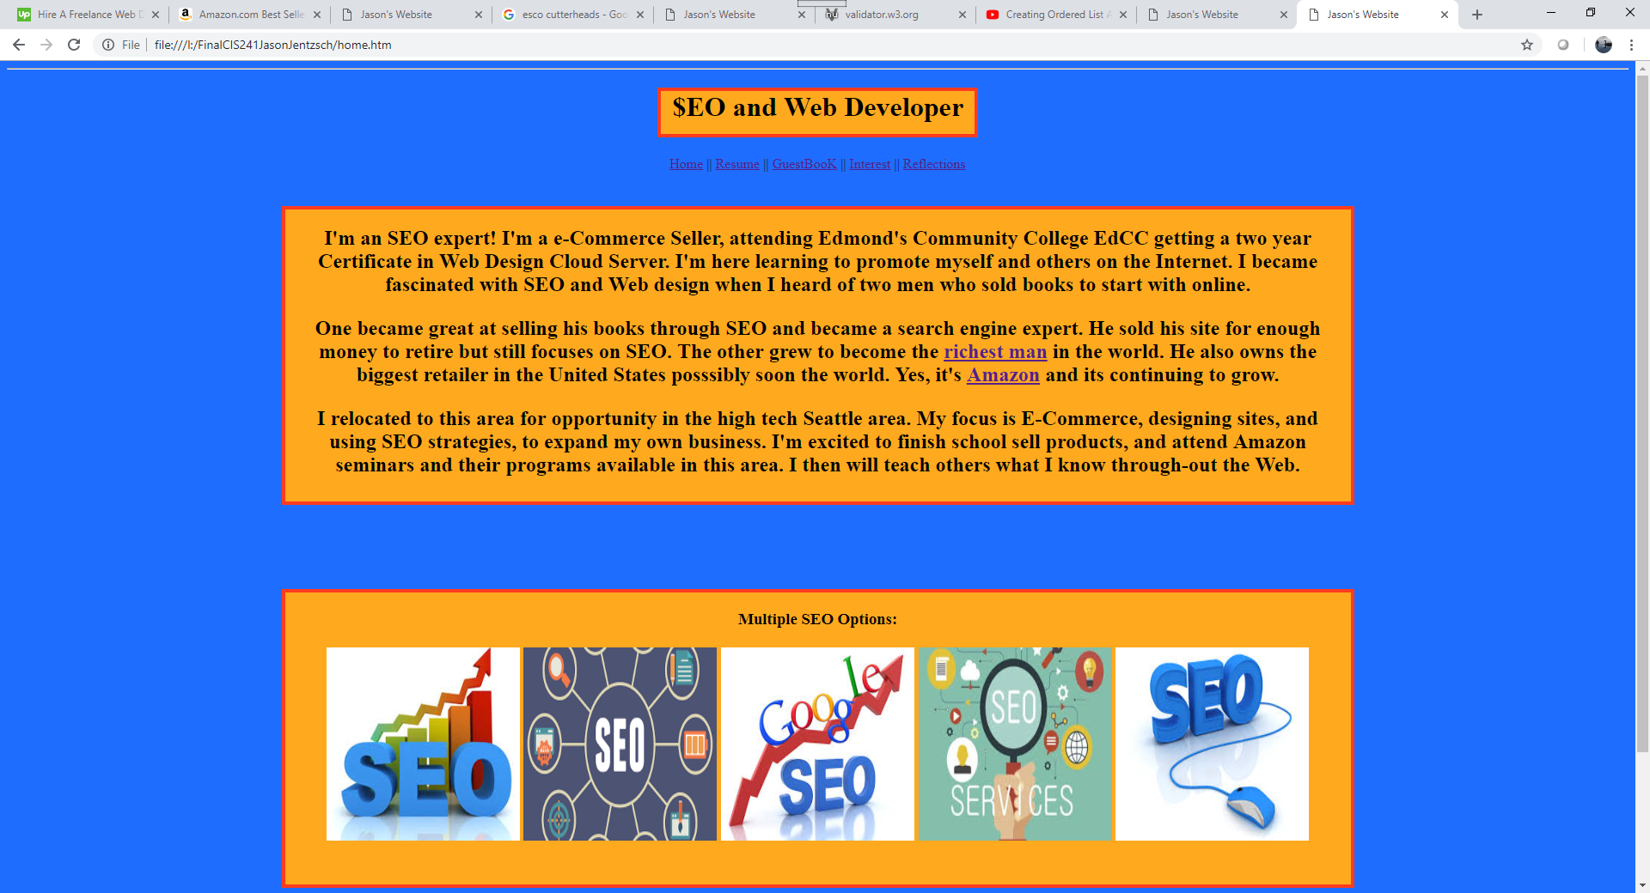

Home Page B; 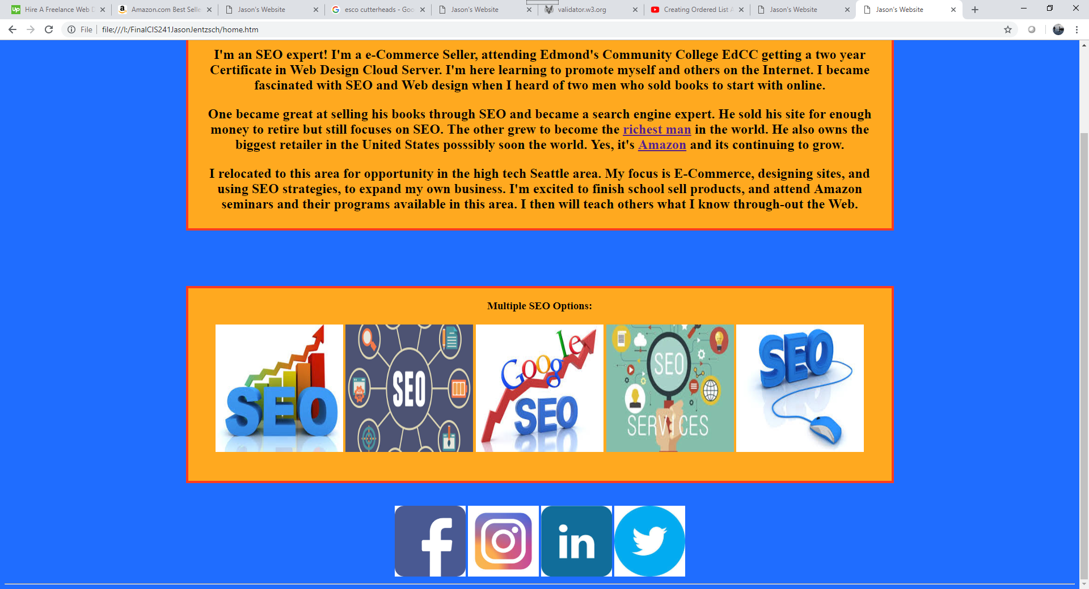

Resume page A; 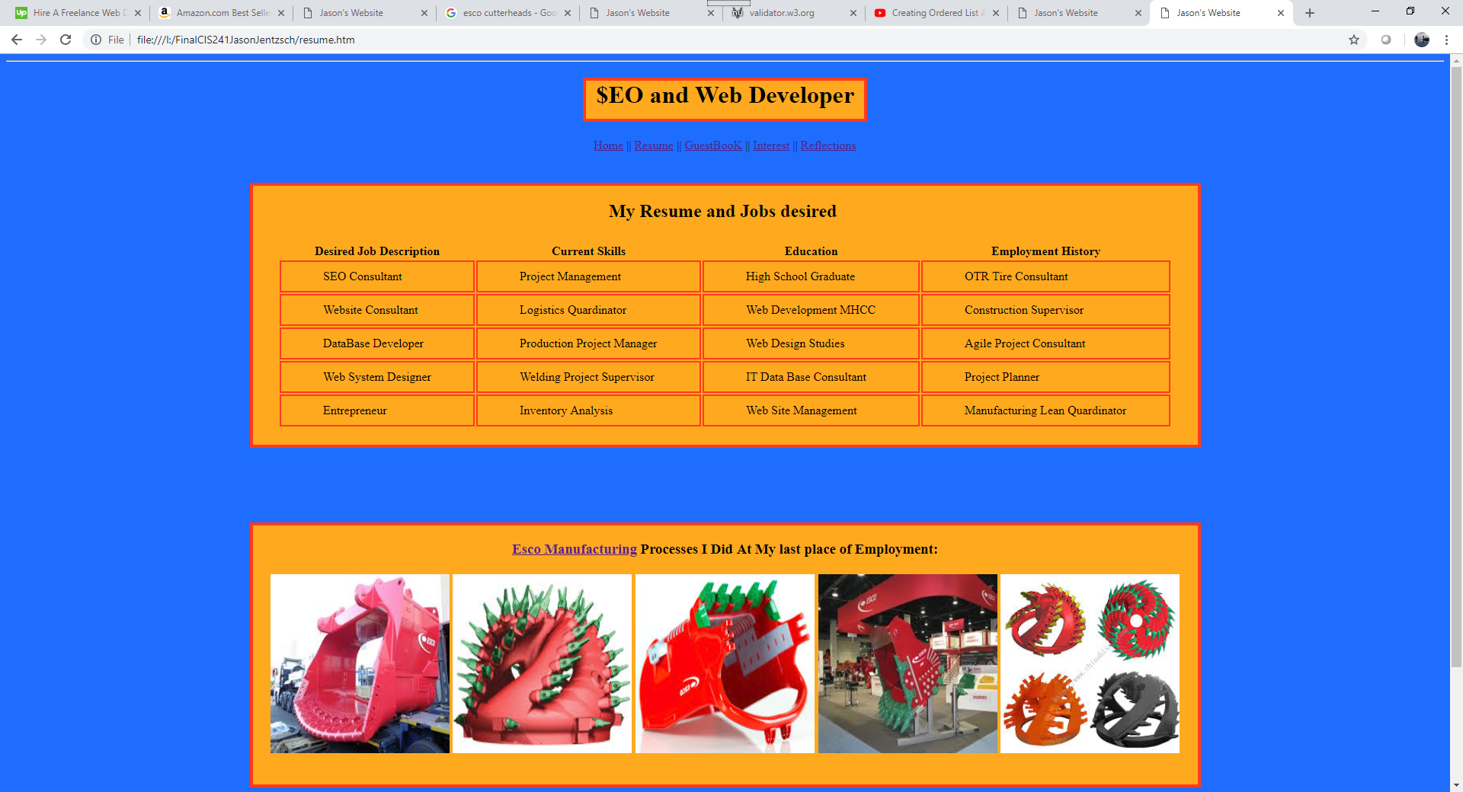

Resume Page B; 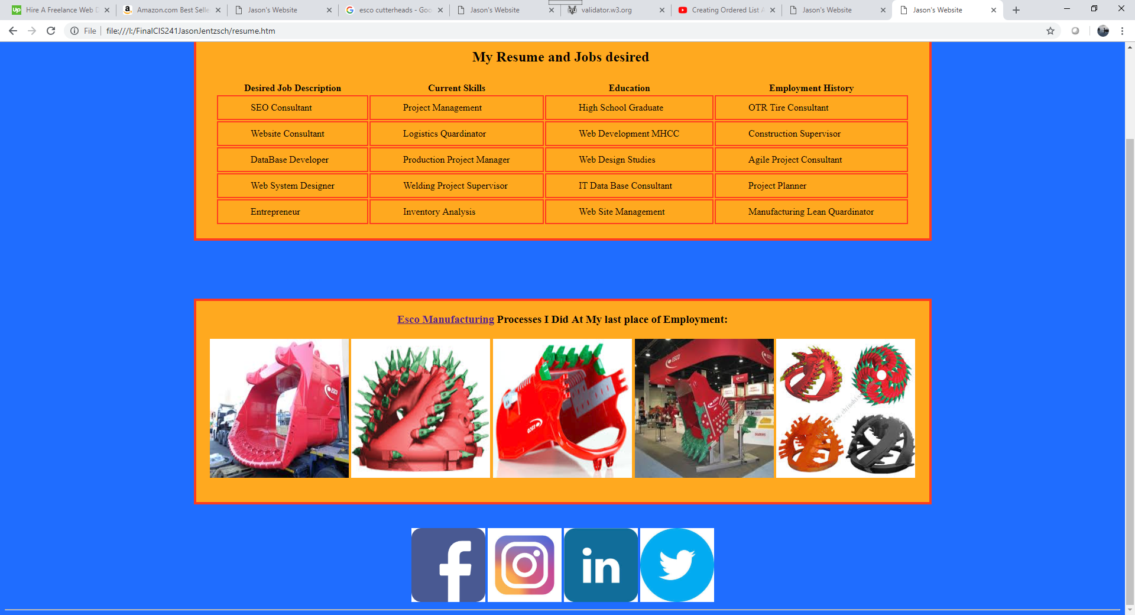

Page GuestBook A; 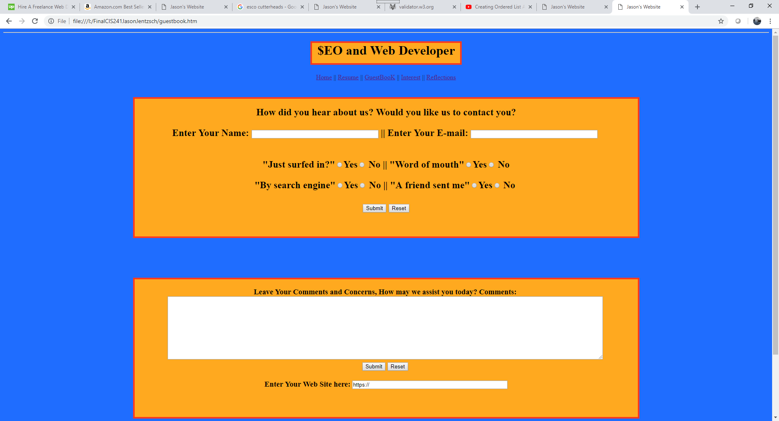

Page GuestBook B; 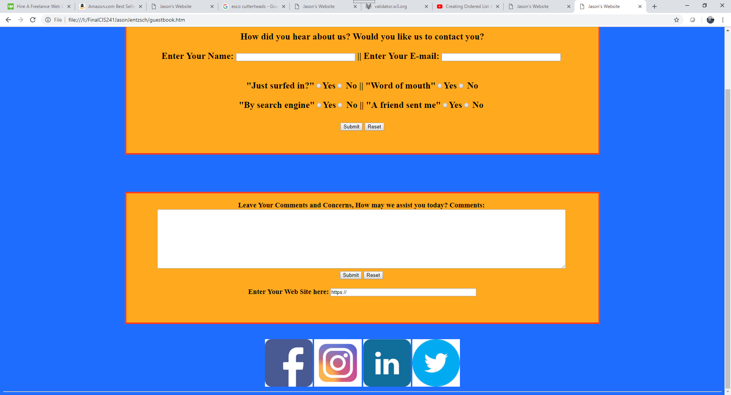

Interest Page A; 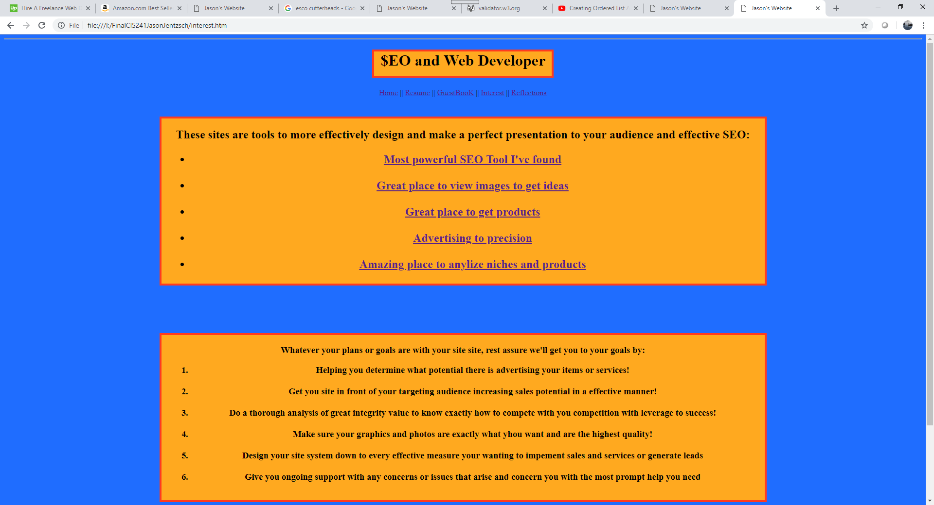

Interest Page B; 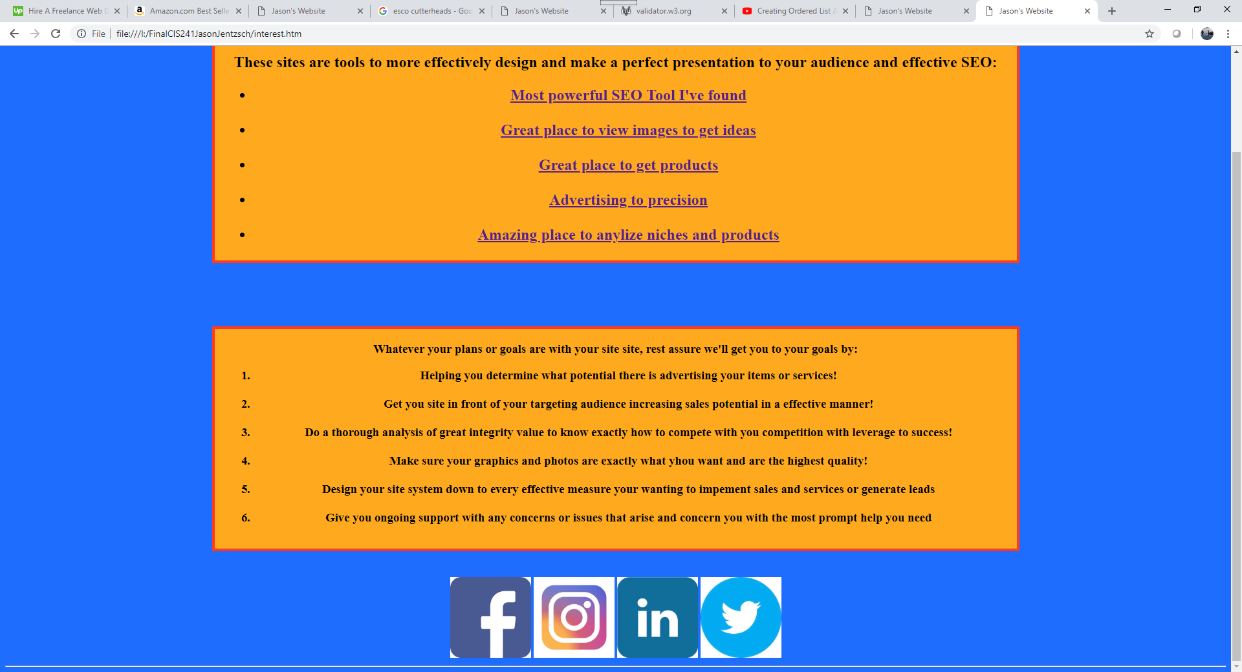

Reflections Page A; 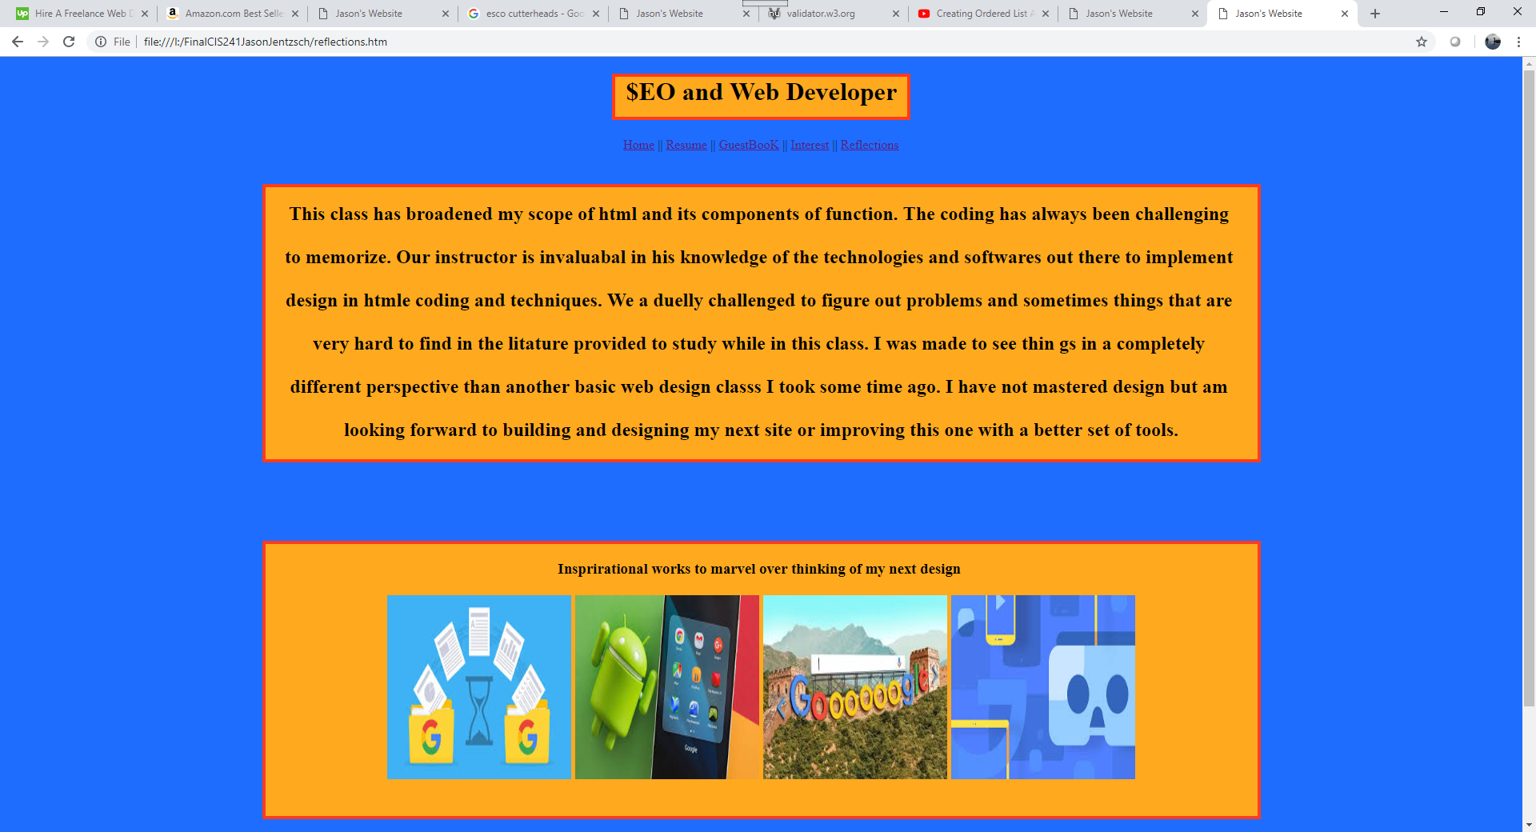

Reflections Page B; 